Before the occultation During the occultation
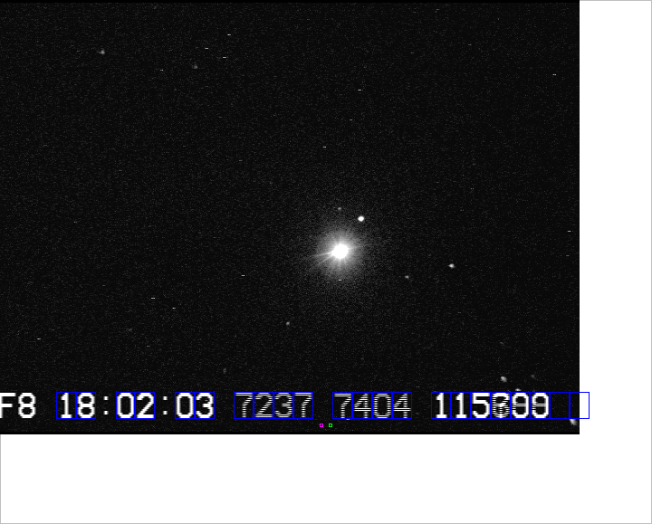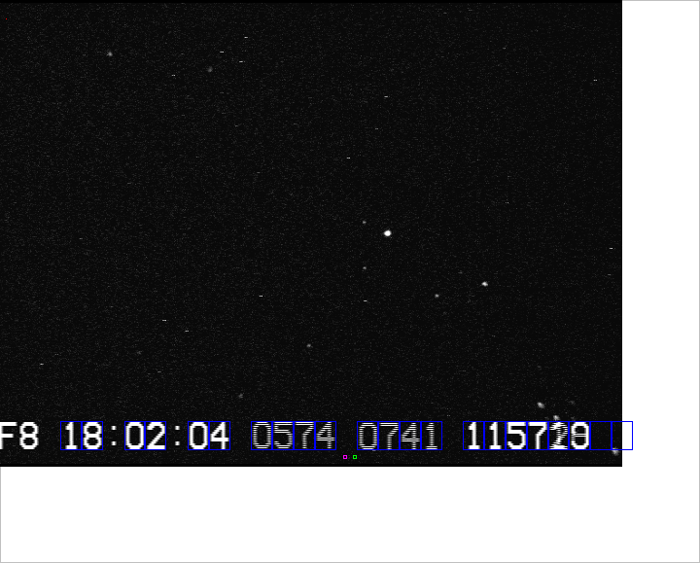

Occultation of the star Regulus by the asteroid (268) Adorea on October 14, 2016, observed in New Ireland, PNG by David and Joan Dunham
.

