Tips for remotely located TTSO presenters

TTSO conferences use a web-based conferencing system called MeetCheap for streaming the presentations to the internet, and also for people presenting their talk from home (rather than at the TTSO conference venue). This document contains instructions & tips for the latter case.
First, some tips about the presentation itself;
First, MeetCheap will only work with Microsoft PowerPoint presentations. As far as I know, it will work with all versions of PowerPoint but I strongly recommend you double check your version with a small file (perhaps 2 slides) before you get too far with preparing your presentation (and definitely before the conference). If you find it won’t work with your version, try saving the file in an older version (and let me know the problem so I can update this document for future TTSOs). Similarly, if you use a non-Microsoft program such as OpenOffice, try exporting the presentation as a PowerPoint.
The next tip regards animations, e.g. where you have the next bullet point fly in when you click in the slide. When a presentation is uploaded to MeetCheap it is also converted (flattened?) by MeetCheap (don’t ask me what to). The result is the animation itself (the flying bit) is lost and your slide shows the end result of all the animations, e.g. all of your bullet points are shown when you move to that slide. I haven’t tried hypertext links and embedded videos but I suspect they won’t work.
MeetCheap can also upload and play a video. According to MeetCheap it will play .flv, .f4v, .mp4 and .mov video formats but points out this will depend on these being supported on the guests’ computers. I’ve only explained the procedure to upload and play presentations in this document, but once you’ve mastered that you shouldn’t have any problem with uploading and playing videos as the procedure is very similar.
Finally, there are limits of the file size allowed (50MB) and number of slides in a presentation (50).
I have set up a link to MeetCheap on the Occultation Section’s website http://www.occultations.org.nz/. Navigate to the section of the website talking about the current TTSO to find the link. For the impatient, I have copied that link for the current conference (TTSO14) here: https://murray-forbes.myownmeeting.net/
After a few seconds the following login screen will pop up;
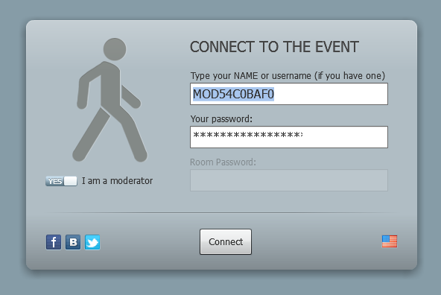
I have set up a special username (MOD24ACD7EC) for remote presenters – do not include the (). Make sure the ‘I am a moderator’ button is set to ‘YES’ and then enter the password (L6A5G2A1).
MeetCheap uses your PC’s microphone and webcam. The next screen shows how to set these up in MeetCheap - click ‘Settings’ near the top-right of your screen, the ‘Audio/Video’ tab and the video camera icon above the word ‘camera’. Your browser may ask you for permission for MeetCheap to use these. For TTSO presentations, the webcam is optional – but we must be able to hear you speak. Click ‘allow’. If you have a webcam, this will turn on and you will see yourself. You should also be able to test your microphone. Finally, close the ‘Are you ready to broadcast’ window.
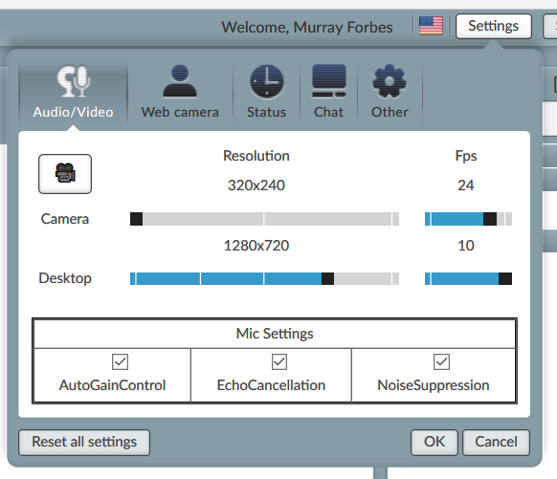
You will now find yourself in the ‘chat’ window, where you can type text messages to everyone else who has connected to TTSO’s MeetCheap and read their messages.
When the two moderators (‘Murray Forbes’ and ‘guest presenter’, i.e. yourself) are both logged in you may see the ‘Unlock tabs’ button to the left of the other tabs (which will be all greyed out). You need to click this to access the other tabs, especially the ‘presentation’ tab when you want to give your presentation.
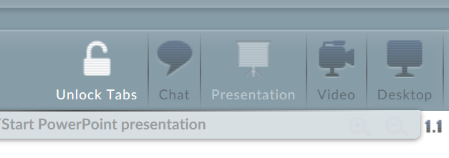
So the next thing you will want to do is change to the ‘Presentation’ window. The control button to do this is on the top-right of your screen;
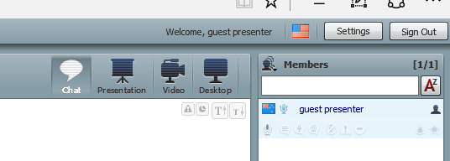
This brings you to the Presentation screen below, where you can see a yellow pop-up tip. So click on the ‘Upload/Start PowerPoint presentation’ tab.

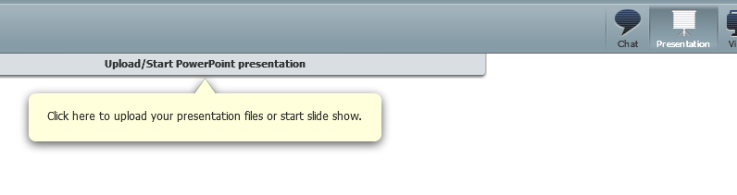
Here you will see a list of presentations that have already been uploaded to MeetCheap for broadcasting. In the image below, only one has been uploaded so far (one of my presentations). Please also note the restrictions about the size of your presentation etc.
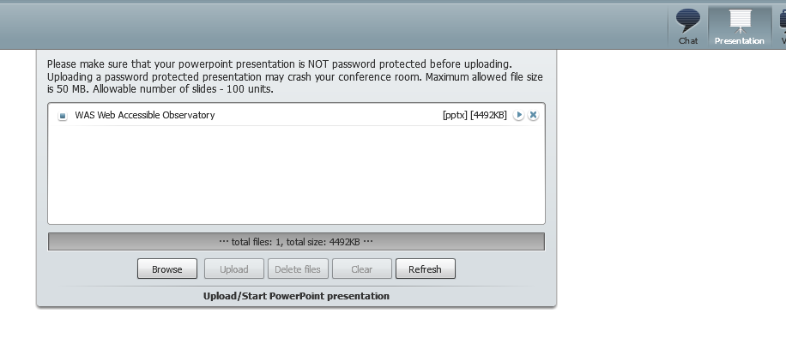
Click the ‘browse’ button to open up a navigation window to allow you to select the presentation on your PC to be uploaded to MeetCheap;
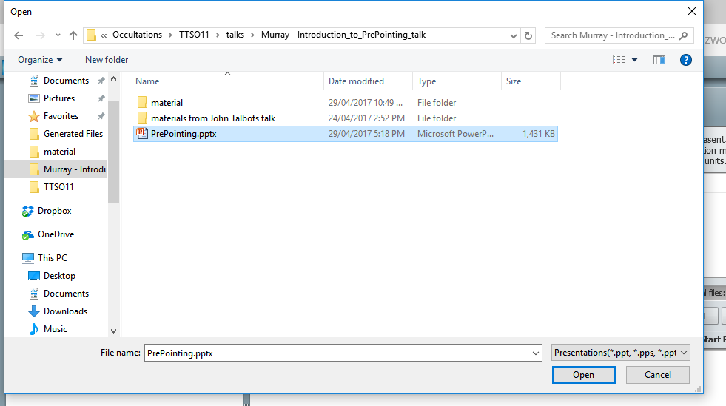
Then click the ‘Upload’ button. This button will then change to read ‘cancel’ and a progress bar for the download is displayed.
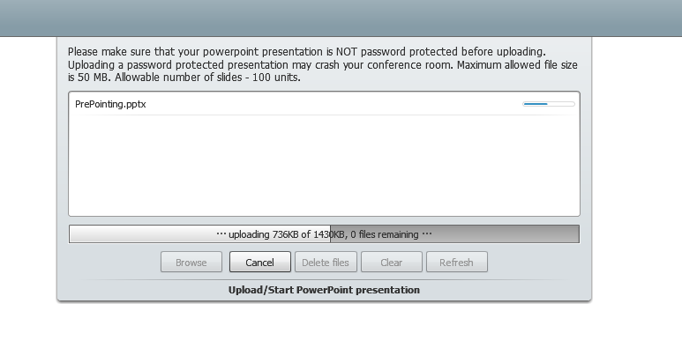
Once the presentation has been uploaded, MeetCheap will process the file into the format it requires. When finished, you can run a presentation by pressing the corresponding ‘play’ button.
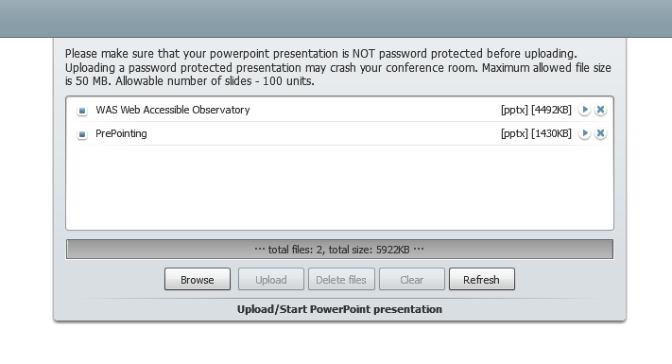
This will bring up the first slide of the presentation. Everyone connected to this MeetCheap conference (including everyone at the actual TTSO conference, via the projector connected to one of my laptops) will now also be seeing this. Next click the ‘Talk Now’ button.
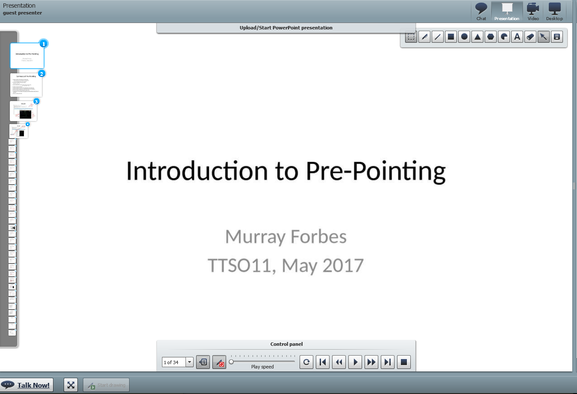
The ’talk now’ button will change colour from blue to red.
To bring up the controls for controlling your slides click the ‘control panel’ bar;
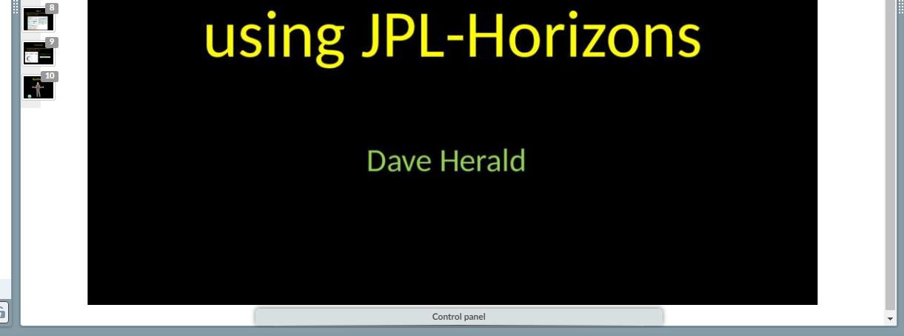
To move to your next slide, click the >> button. Do not use the > button, as this starts a timer to automatically move to the next slide (the default time is every 5 seconds).
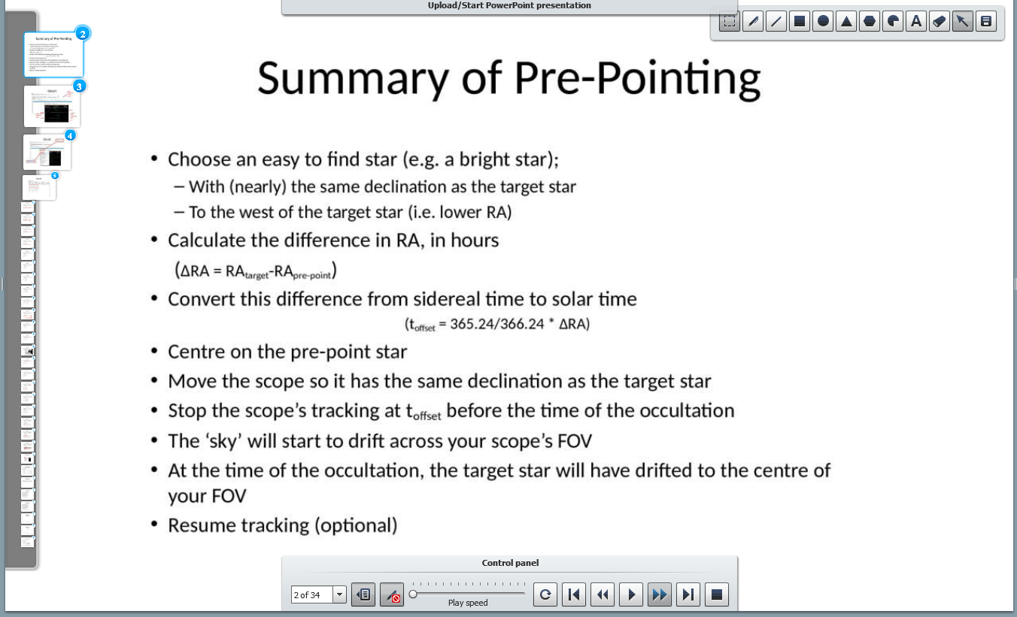

Once the presentation (and question time) is over, please ‘sign out’ so the next presenter can get ready for their talk. If you wish to view this (next) talk, just sign in as an ordinary (‘moderator’ = ‘no’) guest as per the instructions on the Occultation Section’s website.
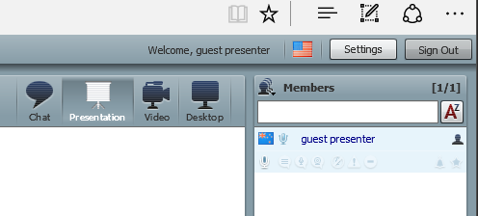

Murray Forbes.

